Robot Report
The main purpose of a technical report is to present facts and conclusions of a design or project [1]. Technical reports should aim at ease of information retrieval and readers should be able to read selected sections without need to read the full document [2].
Genre: Technical Report.
Purpose: Present details of the robot you built and the process of building it.
Audience: The Robot Report is intended for an audience of knowledgeable engineering freshmen.
Identity: You should write and present as a design engineer.
Attitude: Inform your audience about the great project you just completed.
Due date: One week after report is announced.
Format details according to modified IEEE (see below).
Grading: All section have equal weight.
Autonomous Spider Robot Report

Project Title
Team Number:
Team Member Name | Signature | Date
Carlos Boza |  | 4/15/2015
Carlos Flores |  | 4/15/2015
Kevin Baza |  | 4/15/2015
Makala Reid |  | 4/15/2015
Zain Akhtar |  | 4/15/2015
Team Leader: Kevin Baza

Abstract— The autonomy, and thus utility of a robot, can be greatly enhanced by its ability to sense the environment around it. Robotic sensing can give robots the capability to interact and respond to their surrounding environment through the detection and input from external factors. The objective of this assignment was to program a robot that could independently navigate its way across a room and chart a path parallel to the room’s walls. This program provided students with an opportunity to explore the basic foundations of programming, coding, and circuitry, all of which are significant skills to the development of engineering students. Each team was given a robot they had to assemble and passive infrared (PIR) motion sensors; the robot was constructed to resemble a spider and consisted of a plastic frame, eight plastic legs, two motors, and jumper cables. Students used the open-source Arduino Software (IDE) to write a code and upload it to the board attached to the robot. Ideally, the outcome of this venture should be that the robot operates faultlessly, meaning that if placed in a walled room it would follow the parameters of the program to locate a wall and circumnavigate the perimeter of its environment while being able to circumvent any impediments to its objective.
Keywords—robot; arduino (key words)

Introduction
A robot is a manmade mechanical device that can is primarily used to help us perform task more efficiently or safely. There are many types of robots and are usually built based on their intended function. For example welding robots are made of and arm on multiple joints and are used for manufacturing. The military uses Robots called EOD’s (explosive ordnance disposal) [3]. For this project we started out with a basic robot with batteries and an on/off switch. We made a second robot and combined the two so we could have a motor running each side of the robot. We then added a Romero and programmed it. Our goal was to ultimately make the robot autonomously move against a wall a certain distance parallel to the wall without any collisions. The report is broken up into 6 sections. The first 3 sections give you an overview of the project. Section 4 gives you a rundown of the project including how it functions. The 5th section shows you the results of the project. The last section shows you what code we used for the project and includes comment lines to explain the functions in the code.

Problem Statement
Our group wanted to create an autonomous robot that could navigate across a four-walled room while avoiding collisions.

Objectives
1. Autonomously navigate around a 4-walled room. 2. Move around the room, following a path parallel to the walls.

Constraints
1. The spider must stay exactly 15cm away from the walls.
2. The spider has to move indefinitely (until powered off).
3. The spider must have three sensors.

Project Description
Our robotic spider functions through the power of four batteries and two motors, the application of a front sensor and one side sensor and the command of a code initiated via computer, through the Romeo board. The purpose of our robot is to function without the intervention of a human; and functioning means to navigate a specified distance parallel to sensed obstacles (Movement figure above), stabilizing if straying off the specified distance, in an attempt to move indefinitely, and avoid collision as well as impediment, given enough power (stabilizing figure above).

End Product Description
Figure 1 displays the main function that controls the autonomous spider robot. Once the spider is powered on, the motors are stopped (just in case they are already running). The “Find a Wall Function” is then executed (Figure 2 displays this function). The purpose of this function is for the spider to find any wall in the room, and turn so that its left side is parallel to the wall. In this function, both the left and right motors are turned on (forward relative to the spider) as long the left sensor detects an object at a distance greater than 20 units. Once the left sensor reads a distance less than 20, the right motor is turned off, and after 1000ms, the left motor is turned off (this turns the spider to the right, allowing the robot to align parallel to the wall). Figure 1 displays that once the “Find a Wall Function” has been executed (it is only executed once), the “Move Forward Function” is then called (shown in Figure 3). In this function, both motors are turned on (forward relative to the spider) as long as the front (or center) sensor detects an object at a distance greater than 20 units. Figure 1 displays that the “Stabilize Function” is now called upon (shown in Figure 4). The purpose of this function is to keep the spider parallel to the wall at a distance of 20 units (if it strays from this distance, it will return to 20 units). If the left sensor detects an object at a distance less than 20 units, it will turn right, and if it detects an object at a distance greater than 20 units, it will turn left (see the Stabilize figure in the III. Product Description section). Figure 1 shows that the “Corner Turn Function” is then called upon (shown in Figure 5). The purpose of this function is to allow the spider to turn in case of a corner (where it will then become parallel to the wall where it was previously perpendicular to, relative to the front of the spider, see the movement Figure from the III. Product Description section). In this function, if both the front and left sensor detect an object at a distance 20 units away, it will turn right by reversing the right motor, while keeping the left motor moving forward. Figure 1 shows that the program will once again loop to the “Move Forward Function”, and continue to execute the “Move Forward” “Stabilize” and “Corner Turn” functions until the spider is no longer receiving power.
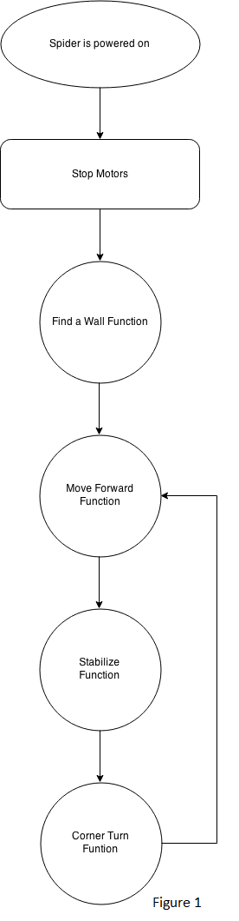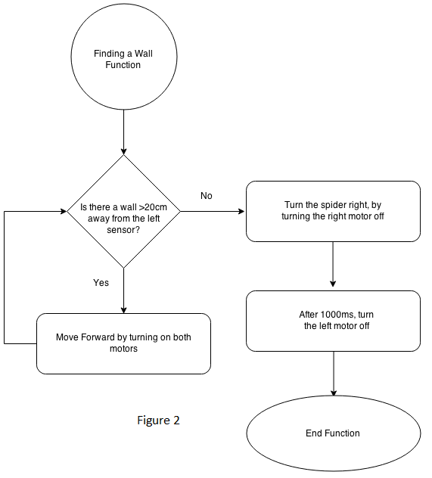
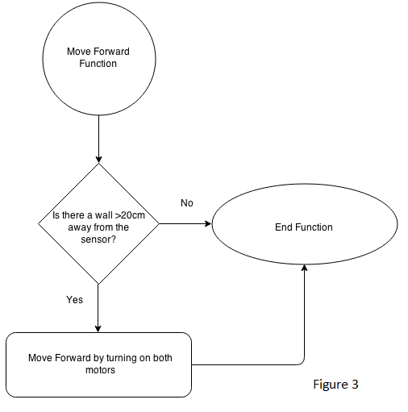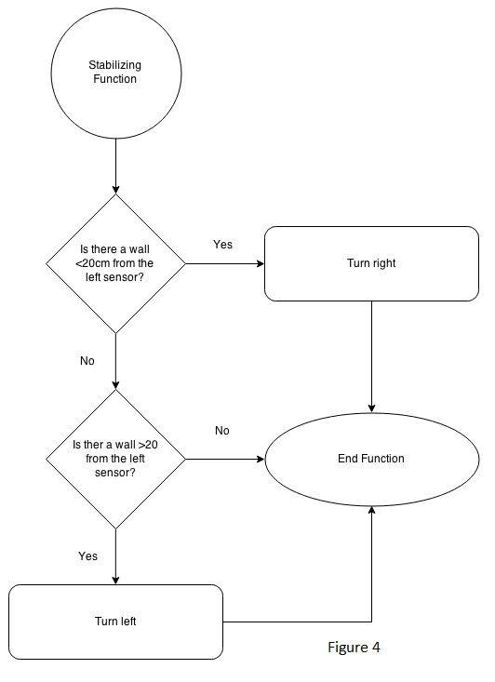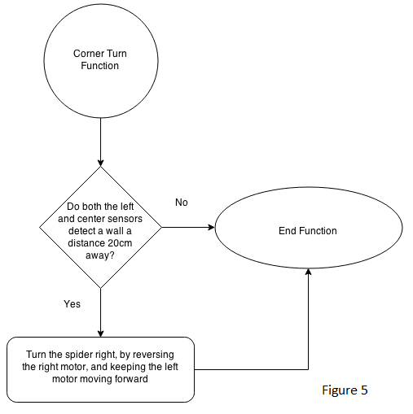

Results Evaluation
Unfortunately, we were unable to successfully reach our objectives. We tested the robot using very simple code (simply to test the motors) and although the motors moved, it seems they don’t receive enough power, because once it was placed on a surface, it barely moved. We wrote a program that would possibly allow us to reach our objectives, but unfortunately have been unable to test it for the complications stated earlier. We tested both sensors, and have verified that they give accurate readings, however, again, we have been unable to test it (in the application of our “finished” program). A possible solution to our problem, is to use a larger source of emf (in terms of Voltage), possibly 18V.

Programming Code
#include <Atv.h>
Atv leftSensor(0), centerSensor(1); // Creates two instance of Atv, one for left sensor, one for center sensor
int LEFT = 0, DOWN = 0; // Backward direction, Left and Down
int RIGHT = 1, UP = 1; // Forward direction, Right and Up
int ledtDistance, centerDistance;

void setup() {

// Just to know program is running
Serial.begin(9600);
Serial.println("Hello");

// Make sure both motors are stopped
leftSensor.moveMotorDF(1, LEFT, 1, 0);
leftSensor.moveMotorDF(2, LEFT, 1, 0);

// Wait some time to set robot in start position
delay(2000);

// Robot will find wall if set at convenient angle
findWall();
}
void loop() { //Here, the forward, stabilize and cornerTurn functions are called upon (respectively)
forward();
stabilize();
cornerTurn();
}
void findWall(){
// Get distance to left wall. Left sensor
ledtDistance = leftSensor.distance();
// "While loop" will move motor forward until left sensor is close enough to the wall
while(ledtDistance > 20){
// Move forward. Motors were wired to move forward this way
leftSensor.moveMotorDF(1, LEFT, 3, 40);
leftSensor.moveMotorDF(2, LEFT, 3, 40);
// Refresh distance to left wall. Left sensor
ledtDistance = leftSensor.distance();
// Next two lines good for debugging
Serial.print("Distance: "); // This line is optional if you want to monitor distance in the computer
Serial.println(ledtDistance); // This line is optional if you want to monitor distance in the computer
}
// Position robot to follow left wall
leftSensor.moveMotorDF(1, LEFT, 3, 0); // Stop right motor to align with wall
delay(1000); // Continue for certain amount of time
leftSensor.moveMotorDF(2, LEFT, 3, 0); // Stop the other motor
}

void forward(){ //This function simple makes the spider move forward as long as the center sensor does not sense a wall within 20 arbitrary units
centerDistance = centerSensor.distance();
while(centerDistance > 20){

temp = atv.distance();
atv.moveMotor(1, LEFT, 3, 40); //Here both motors are moving forward
atv.moveMotor(2, LEFT, 3, 40);
Serial.print("Distance: "); // This line is optional if you want to monitor distance in the computer
Serial.println(temp); // This line is optional if you want to monitor distance in the computer
}
}

void stabilize(){
ledtDistance = leftSensor.distance();
if (ledtDistance < 20 ){ //Will only execute the command below if the left sensor detects an object at a distance less than 20 units
leftSensor.moveMotorDF(1, LEFT, 3, 0); // Stops the right sensor, so the spider turns right
delay(1000);
}
if (ledtDistance > 20 ){ //Will only execute the command below if the left sensor detects an object at a distance greater than 20 units
leftSensor.moveMotorDF(2, LEFT, 3, 0); //Stops the left sensor, so the spider turns left
delay(1000);
}
}

void cornerTurn(){
centerDistance = centerSensor.distance();
ledtDistance = leftSensor.distance();
if (ledtDistance && centerDistance == 20){ //The following commands will only execute if both the left sensor and center sensor detect the same distance (20 units)
leftSensor.moveMotorDF(1, RIGHT, 3, 40); //Runs the right motor backwards
leftSensor.moveMotorDF(2, LEFT, 3, 40); //Runs the left motor forward, so the whole spider is turning right
delay (1000);
}

}

References

[1] “Descriptions of the common genres assigned in your major.” [Online]. Available: http://www.csus.edu/wac/WAC/Students/Major%20Sites/computer_engineering_genres.html. [Accessed: 21-Jul-2014].
[2] “The undergraduate report and essay: an analysis of the relevance of each genre to the writing skills required by a professional engineer.” [Online]. Available: http://www.ijee.ie/articles/999985/article.htm. [Accessed: 21-Jul-2014].
[3] Bomb Disposal Robot from Johns Hopkins Researchers ENGINEERING.com. (n.d.). Retrieved April 16, 2015, from http://www.engineering.com/DesignerEdge/DesignerEdgeArticles/ArticleID/5891/Bomb-Disposal-Robot-from-Johns-Hopkins-Researchers.aspx

